- There was a small upside surprise for UK CPI inflation in December, following a rise in tobacco duty. But wholesale gas prices have declined further in recent weeks, and we now think inflation will fall by more than we had previously expected. We now forecast CPI inflation will average 2.1% in 2024.
- After edging up in January, we expect inflation to fall sharply in the following few months, returning to the Bank of England's 2% target as early as April. As well as a double digit decline in the energy price cap in April, strong base effects will come into play in the food category and core pressures should continue to weaken.
CPI inflation rose to 4% in December, from 3.9% in November. The small increase mostly reflected December's jump in tobacco duty, while there was a more normal m/m rise in services prices, after a string of weak outturns. RPI and RPIX inflation both fell 0.1ppt to 5.2% and 4% respectively in December.
Inflation will likely edge up again in January, as the increase in the energy price cap takes effect and core inflation is boosted by the comparison with a particularly low outturn in the same month in 2023. But inflation should then fall sharply over the following few months, returning to the Bank of England's 2% target as soon as April.
All the major components will either be dragging on CPI inflation or making smaller positive contributions by April. Food price inflation is likely to cool rapidly as the category benefits from favourable base effects. Core pressures should continue to soften, particularly as firms pass on their lower energy costs to consumers. Despite geopolitical-related volatility, we expect oil prices to stabilise at lower levels than last year. And wholesale gas prices have fallen sharply, meaning that the Ofgem energy price cap is now on track to fall by 14% in April.
The continued fall in gas prices since our December update has resulted in us lowering our 2024 CPI inflation forecast by 0.3ppts. We now expect CPI inflation to average 2.1% this year.
Chart 1: Recent declines in gas prices have lowered our 2024 inflation forecast to 2.1%
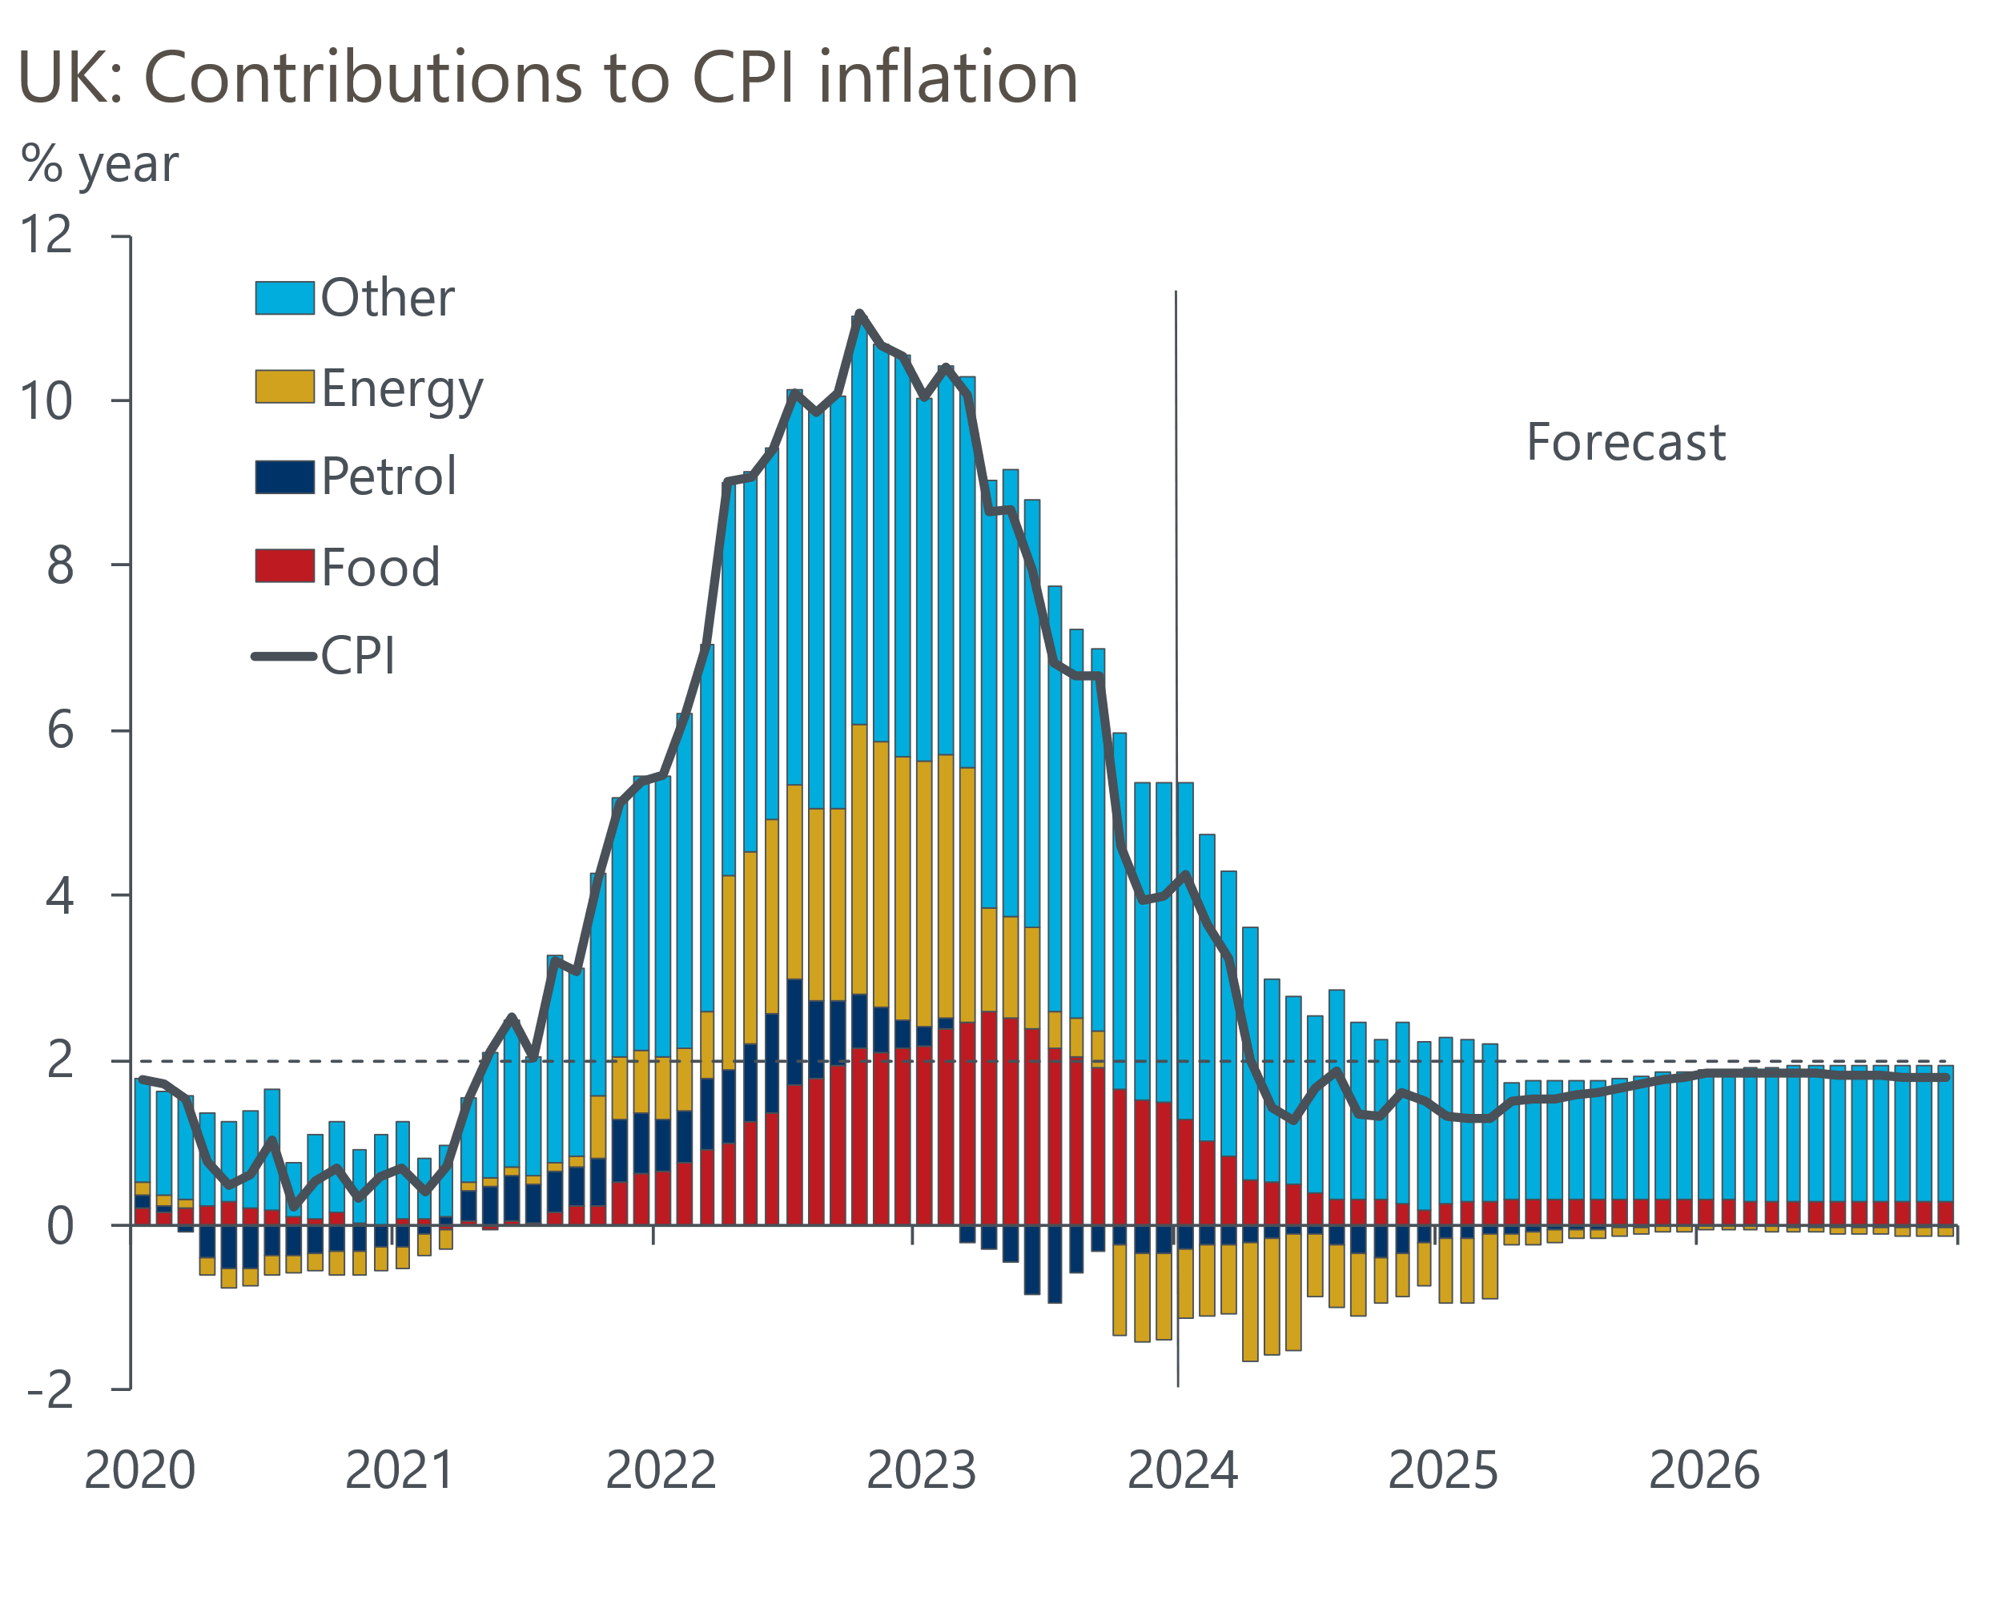
Sources: Oxford Economics, Haver Analytics

